**Ideation Phase**

**Brainstorm & Idea Prioritization Template**

|  |  |
| --- | --- |
| Date | 26 JUNE 2025 |
| Team ID | LTVIP2025TMID59973 |
| Project Name | Citizen AI-Intelligent Citizen Engagement Platform |
| Maximum Marks | 4 Marks |

**Brainstorm & Idea Prioritization Template:**

An AI-powered citizen engagement platform can enhance democratic participation by improving communication, gathering feedback, and streamlining decision-making. Brainstorming ideas should focus on key areas like AI-driven translation for multilingual engagement, sentiment analysis to gauge public opinion, personalized information delivery, and efficient issue resolution. Prioritization should consider factors like impact, feasibility, and alignment with city goals.

Brainstorming ideas for such a platform should focus on personalization ,accessibility, proactive problem-solving and efficient communication. Prioritization can be achieved by considering factors like impact, feasibility and ethical considerations.

**Step-1: Team Gathering, Collaboration and Select the Problem Statement**

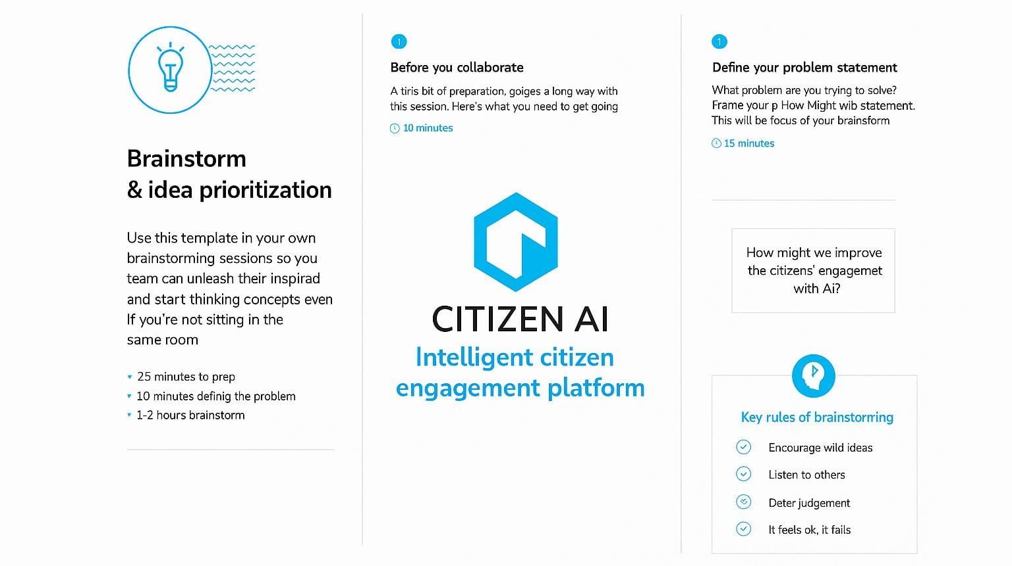

**Step-2: Brainstorm, Idea Listing and Grouping**

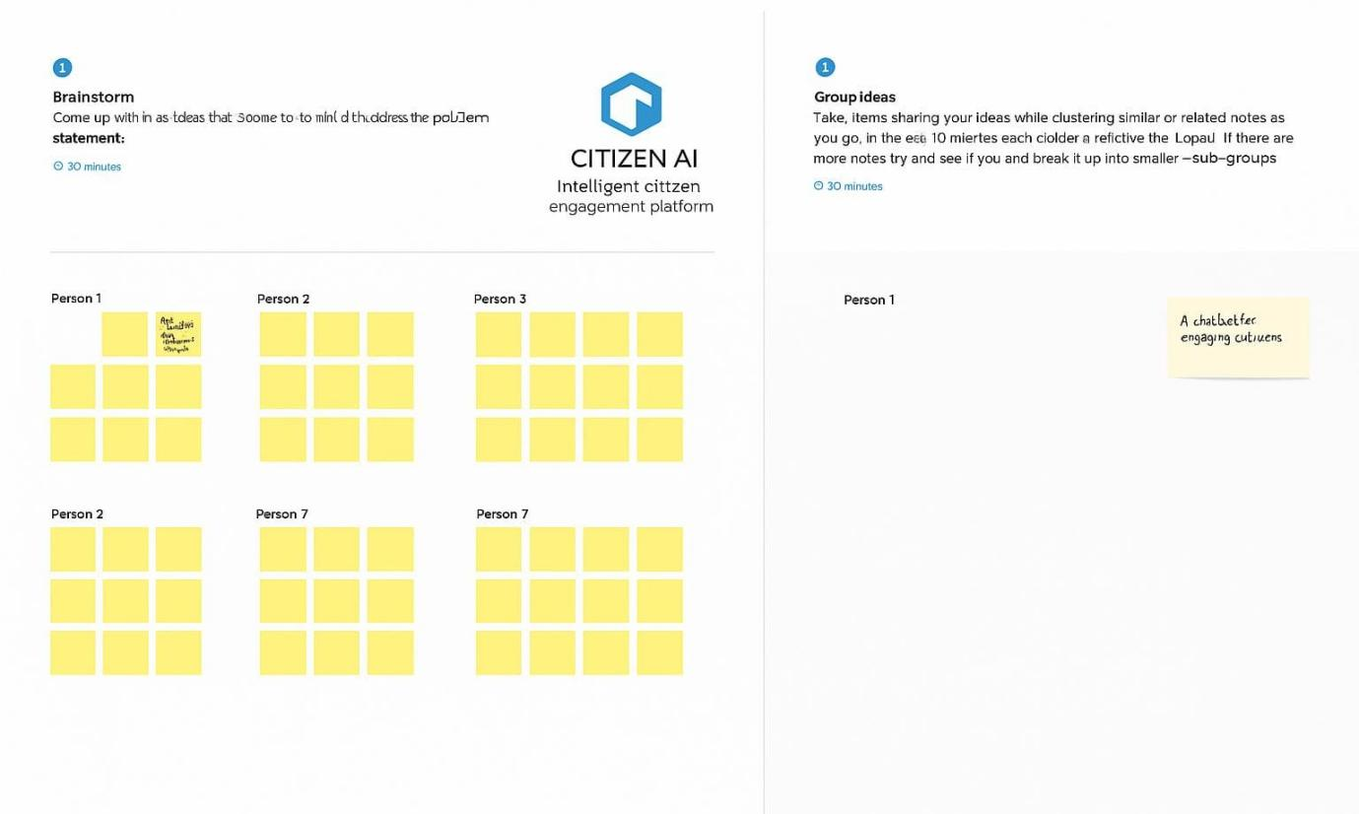

**Step-3: Idea Prioritization**

